Employed 2011:



Unemployed 2011



Socio cat 1 - skilled



Socio cat 2 - unskilled



2011 – Educated



Uneducated 2011

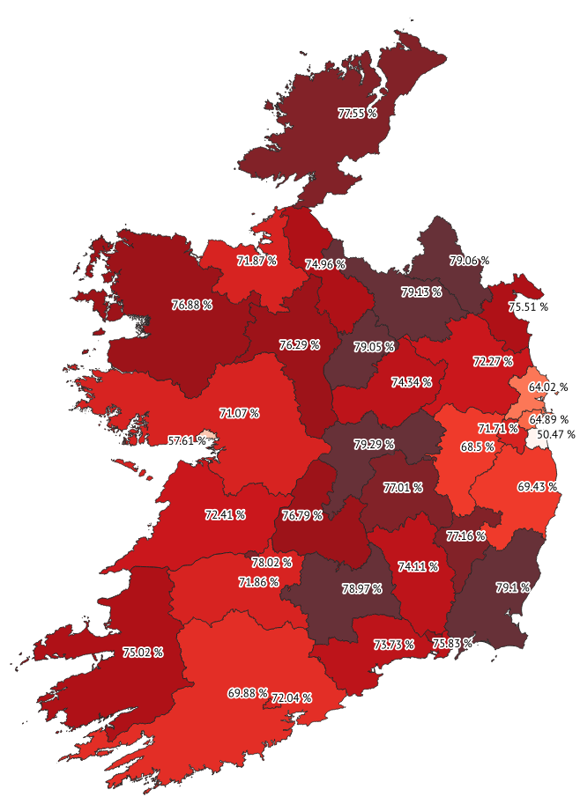

Employed2016 - greens



Unemployed 2016 – color ramp Viridis

